Network Data Structures

🧠 What Are Network Data Structures?
# Source: AI Source: Provided by: [Data Path: Persons Table -> ID Column: 1, Name_En Column: Motasem Essam] -> From: [ChatGPT] on [1/16/2026]
Network data structures refer to the ways data is organized, formatted, and transferred within computer networks. These structures are logical or physical formats used to represent network data for efficient communication, routing, and processing between devices.

🧠 Simple Definition:
# Source: AI Source: Provided by: [Data Path: Persons Table -> ID Column: 1, Name_En Column: Motasem Essam] -> From: [ChatGPT] on [1/16/2026]
Network data structures are organized forms of data (such as packets, frames, and headers) that computers and network devices use to send, receive, and interpret data across a network.

🧱 Common Types of Network Data Structures
# Source: AI Source: Provided by: [Data Path: Persons Table -> ID Column: 1, Name_En Column: Motasem Essam] -> From: [ChatGPT] on [1/16/2026]
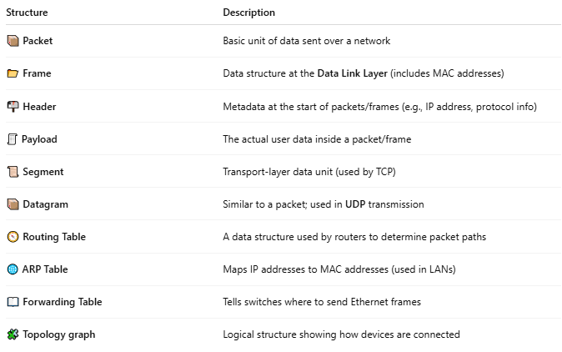

Structure | Description
📦 Packet | Basic unit of data sent over a network
📂 Frame | Data structure at the Data Link Layer (includes MAC addresses)
📬 Header | Metadata at the start of packets/frames (e.g., IP address, protocol info)
🧾 Payload | The actual user data inside a packet/frame
📜 Segment | Transport-layer data unit (used by TCP)
📦 Datagram | Similar to a packet; used in UDP transmission
🧭 Routing Table | A data structure used by routers to determine packet paths
🌐 ARP Table | Maps IP addresses to MAC addresses (used in LANs)
📖 Forwarding Table | Tells switches where to send Ethernet frames
🧩 Topology graph | Logical structure showing how devices are connected

🛠 Example: Packet Structure (Simplified)
# Source: AI Source: Provided by: [Data Path: Persons Table -> ID Column: 1, Name_En Column: Motasem Essam] -> From: [ChatGPT] on [1/16/2026]

| IP Header | TCP Header | Payload (Data) |

- Header: Info about source/destination IP, port, sequence number, etc.
- Payload: Actual data (like part of a file, image, or message)

💡 Key Roles of Network Data Structures
# Source: AI Source: Provided by: [Data Path: Persons Table -> ID Column: 1, Name_En Column: Motasem Essam] -> From: [ChatGPT] on [1/16/2026]
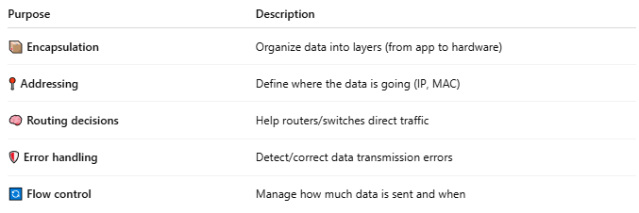

Purpose | Description
📦 Encapsulation | Organize data into layers (from app to hardware)
📍 Addressing | Define where the data is going (IP, MAC)
🧠 Routing decisions | Help routers/switches direct traffic
🛡 Error handling | Detect/correct data transmission errors
🔄 Flow control | Manage how much data is sent and when

🔄 Related OSI Layers and Data Structures
# Source: AI Source: Provided by: [Data Path: Persons Table -> ID Column: 1, Name_En Column: Motasem Essam] -> From: [ChatGPT] on [1/16/2026]
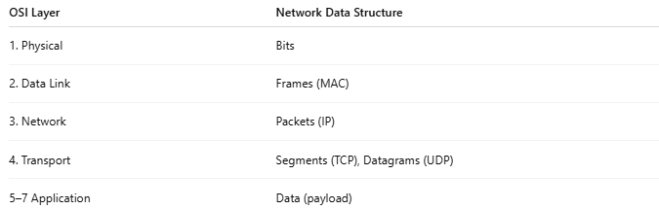

OSI Layer | Network Data Structure
1. Physical | Bits
2. Data Link | Frames (MAC)
3. Network | Packets (IP)
4. Transport | Segments (TCP), Datagrams (UDP)
5–7 Application | Data (payload)

📌 Summary
# Source: AI Source: Provided by: [Data Path: Persons Table -> ID Column: 1, Name_En Column: Motasem Essam] -> From: [ChatGPT] on [1/16/2026]
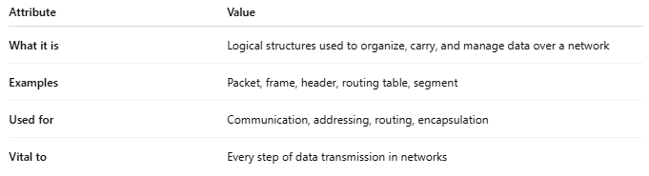

Attribute | Value
What it is | Logical structures used to organize, carry, and manage data over a network
Examples | Packet, frame, header, routing table, segment
Used for | Communication, addressing, routing, encapsulation
Vital to | Every step of data transmission in networks

